双流区黄水小学2019——2020学年度下期期末模拟题3
学校 班级 姓名 考号
…………………………………………………………………………………………………………………………………………………………………………………………
………………………密………………封………………线………………内………………不………………要………………答……………题……………………………
小学六年级英语

- Listen ,tick or cross.听录音，根据录音内容判断图片正误，正确的打√，错误的打×。（每小题2分，共10分）
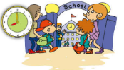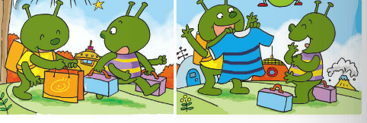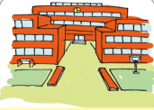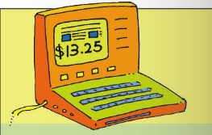
- ( ) 2、 ( ) 3、 ( ) 4、 ( ) 5、( )
- Listen and choose .听录音，根据录音内容选出正确的答案，并把相应的字母填入括号里。（每题2分，共20分）
1、 ( ) A 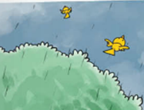 B 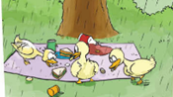
2、 ( ) A 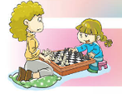 B 
3、 ( ) A 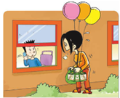 B 
- ( ) A 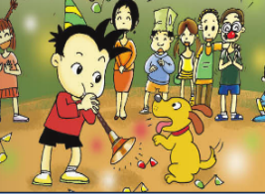 B 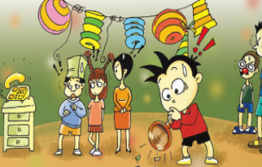
- ( ) A 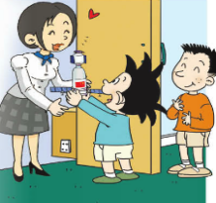 B 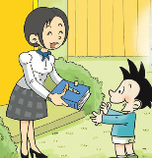
6、 ( ) A 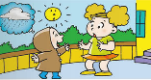 B 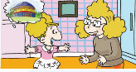
7、 ( ) A  B 
8、 ( ) A 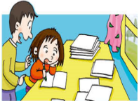 B 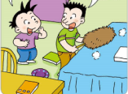
9、 ( ) A 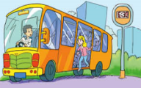 B 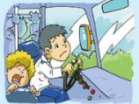
10、 ( ) A 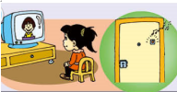 B 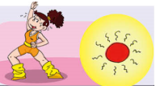

- Listen and number.听录音，根据录音内容给图片排序。（每小题2分，共10分）
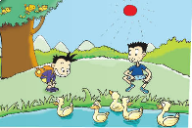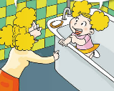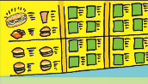
( ) ( ) ( ) ( ) ( )

四、Listen and write.听录音，根据录音内容选词填空。（每小题2分，共10分）

A.because B.different C.leave D.learn E.start

Dear classmates,we are going to 1 our primary school soon and
2 middle school.I’m excited and also sad.
I’m excited 3 we are going to study Chinese,Maths,History,and
4 lots of new things in middle school.I’m very sad to say goodbye
to you.We are going to 5 schools.

五、Listen and choose. 听录音，根据录音内容选择所听到的句子。（每小题2分，共10分）
1、( ) A. Why are you laughing? B. Why are you crying.?
2、( ) A. It was a book about space travel. B. It was a book about Art.
3、( ) A .He’s eating dinner. B. She’s doing her homework.
4、( ) A. Can I help you? B. How much is it?
5、( ) A. She couldn’t hear. B. She could talk.
- Listen and answer.听录音，根据录音内容选择正确的答语。（每小题1分，共5分）
1、( ) A. Because he is sad. B . Because he is a worker.
2、( ) A. I want a hot dog. B. It’s 2 yuan.
3、( ) A. I bought a lot of things. B. I was 2 then.
4、( ) A. I’m going to study History. B. I’m going to fly a kite.
5、( ) A. The birds are singing in the tree. B. I’m cleaning my room.

笔试部分（40分）

- Read and match.读一读，连一连。（每小题1分，共5分）

1、 Where did you go last weekend? A. Because she is happy.
2、 He is walking in the park, B. I’m going to play chess.
3、 What are you going to do tomorrow? C. I went to Chengdu.
4、 Why is she laughing? D. Sorry,I can’t.I’m on the phone.
5、 Who can help me? E、but it starts to snow.

- Choose the right answers to fill in the blanks.选择正确的答案，并把答案的番号填写在题前括号内。（每小题1分，共10分）

( ) 1、 are you crying? Because I’m sad. A Why B How
( ) 2、I’m going to______History and Chinese. A study B look
( ) 3、It’s very cold . I’m going to wear____. A coat B dress
( ) 4、Daming is playing suona, ___the bell rings. A and B but
( ) 5、What did you buy yesterday? I___a new T-shirt. A buy B bought.
( ) 6、___did you go to school?--By bus. A where B How
( ) 7、 It ___ sunny in Harbin. A will be B will
( ) 8、That’s a hot dog. It _________ good. A. look B. looks
( ) 9、When are you going to eat? A. At half past four. B.At the supermarket.
( ) 10、Four years ago,they spoke only very Chinese. A. small B. little

九、Read , then tick or cross. 读短文，根据短文内容判断句子正误，正确的打√，错误的打×。（每小题2分，共10分）
There is a big old tree near my house. A black bird lives in the tree. Every day I take food to the tree. The bird sees me and comes down. The food is in my hand. The bird comes to my hand and eats the food. After that it goes back to the tree. I give some food to the bird every day. And so the bird knows me. I like the bird and the bird likes me. We are good friends.
( ) 1. An old bird lives in the old tree.
( ) 2. I give some food to the bird everyday.
( ) 3. The bird comes to my hand and eats the food.
( ) 4. The bird goes back to the tree after eating food.
( ) 5. The bird doesn’t know me and doesn’t like me.
十、Read and choose. 读一读，选一选。（每小题2分，共10分）
One day a man went home to his wife and said, "I have bought something for you." "Oh, thank you" said his wife. "What have you bought?" "I've bought a gold ring. Here it is.” He held it out for his wife to see. Then he dropped it. "Oh dear" he said. "I have dropped it." He began to look for it on the floor but it was dark inside the house and he could not see anything. He went outside the house and began to look for the ring in the street. Just then a friend came along. "What's the matter?" he asked. "I have lost a ring." said the man. "Where did you lose it?" "I lost it inside my house." "You lost your ring inside your house but you are looking for it outside in the treet. That seems very foolish." "Ah," said the man, "but it is dark inside my house. I shall never find itthere. But here in the street there is lighter and I can see more clearly.
( ) 1.One day a man went to the street to buy a gold ____.
A. watch B. clock C. Ring
( ) 2. He dropped the ring ____ the house.
A. inside B. outside C. in front of
( ) 3. At first he looked for the ring in the ____.
A. street B. shop C. house
( ) 4. Next he looked for the ring in the ____.
A. room B. garden C. Street
( ) 5. Do you think that the man was ____? Yes, I do.
A. clever B. foolish C. Bright
十一、Read and write. 读一读、写一写。（共5分）
Last summer holiday I went to Hainan with my father.We went there by plane.We went swimming there.We were very happy.But this holiday I am going to Beijing with my father.We are going there by plane too.We are going to visit the Great Wall.We are going to take lots of pictures.

