双流区黄水小学2019——2020学年度下期期末模拟题2
学校 班级 姓名 考号
…………………………………………………………………………………………………………………………………………………………………………………………
………………………密………………封………………线………………内………………不………………要………………答……………题……………………………
小学六年级英语

- Listen ,tick or cross.听录音，根据录音内容判断图片正误，正确的打√，错误的打×。（每小题2分，共10分）
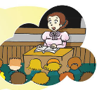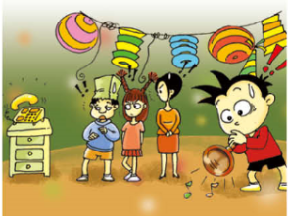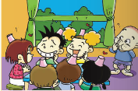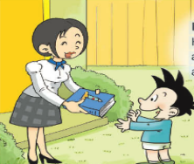
( ) ( ) ( ) ( ) ( )

- Listen and choose .听录音，根据录音内容选出正确的答案，并把相应的字母填入括号里。（每题2分，共10分）
1、 ( ) A 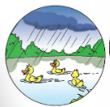 B 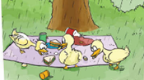
2、 ( ) A 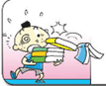 B 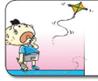
3、 ( ) A 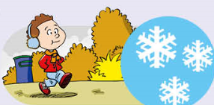 B 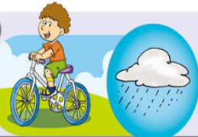
4、 ( ) A 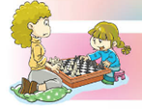 B 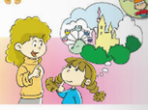
5、 ( ) A 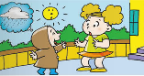 B 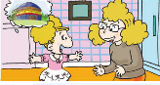

三、Listen and number.听录音，根据录音内容用数字给图片排序。（每小题2分，共10分）
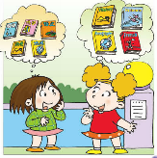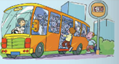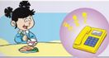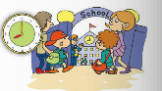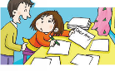
( ) ( ) ( ) ( ) ( )
四、Listen and write.听录音，根据录音内容选词填空。（每小题2分，共10分）
people carry climb important more

Lifts are very to us. Why? Think about a tall building Maybe it has twenty floors. Maybe it has fifty or . Who can walk up all the stairs? Maybe can climb them one time. Can someone thirty floors to an office every day? Can small children walk up to their room on the twenty-fourth floor? Can their mother and father food up all those stairs? Of course not.
五、Listen and choose. 听录音，根据录音内容选择所听到的句子。（每小题2分，共10分）
1、( ) A. Can I help you? B. How much is it?
2、( ) A. He’s eating dinner. B. She’s doing her homework.
3、( ) A. Why do you have cups on your head? B. Why are you laughing？
4、( ) A. It was a book about space travel. B. It was a book about Art.
5、( ) A. The birds are singing in the tree. B. The birds are flying away.

六、Listen and answer.听录音，根据录音内容选择正确的答语。（每小题2分，共10分）
1、( ) A. I want a hot dog. B. It’s 2 yuan.
2、( ) A . I’m going to fly a kite. B. I’m going to study History.
3、( ) A. Because he is sad. B . Because he is a worker.
4、( ) A. They’re having a party. B. They’re books.
5、( ) A. The birds are singing in the tree. B. I’m cleaning my room.

- Choose the right answers to fill in the blanks.选择正确的答案，并把答案的番号填写在题前括号内。（每小题1分，共10分）
( )1、My apples are falling.Who can help me?
- I can help you. B. I’m fine.
( )2、The balloons are _____away. A . fly B. flying
( )3、I’m eating ice cream, because I’m____. A. old B. hot
( )4、Daming is playing suona, ___the bell rings. A. and B. but
( )5、 In this photo, we’re__ _picnic. A. have B. having
( )6、 It ___ sunny in Harbin. A.will be B. will
( )7、 When are you going to eat?
A. At half past twelve. B. At home.
( )8、Simon gave Daming a birthday____. A .cake B. jump
( )9、It’s very cold . I’m going to wear____ . A. coat B. dress
( )10、Helen couldn’t see, but she___read. A. could B. couldn’t

- Read , then tick or cross. 读短文，根据短文内容判断句子正误，正确的打√，错误的打×。（每小题2分，共10分）
Mr. Brown works on a farm. Mr. Green works in a park. But they don’t know each other.
Today is Sunday. Mr. Brown comes to the park. He wants to have a little rest. He sees a red chair under a tree over there. So he walks to the chair. Mr. Green is behind him. Mr. Green runs to the chair with a board when he sees Mr. Brown comes to the chair. But Mr. Brown runs faster. When he is sitting on the chair, Mr. Brown is very happy. But Mr. Green doesn’t say anything. He gives the board in his hand to him. It says, “ Wet paint.”(油漆未干)
( ) 1. Mr. Brown works in a park.
( ) 2. Mr. Green works on a farm.
( ) 3. This story happens on Monday.
( ) 4. Why does Mr. Brown come to the park?
Because he wants to have a swim。
( ) 5. Why doesn’t Mr. Green want Mr. Brown to sit on the chair?
Because it is in wet paint.
- Read and choose. 读一读，选一选。（每小题2分，共10分）
Everybody needs water. All parts need water. We use water to wash cups, cars, clothes and ourselves.
Where does water come from? It comes from the clouds. The clouds can change in to rain. Some of the rain goes down the ground. Some of the rain water goes down the mountains into streams. The streams come together to make rivers and lakes.
Water can change itself. When water gets very cold, it becomes ice. When water gets very hot, it becomes steam.
( ) 1. ___ need water.
A. Only animals B. Only plants C. All living things
( ) 2. We usually clean our clothes with ___.
A. steam B. water C. rain
( ) 3. The water in the streams comes from the ___.
A. river B. lake C. clouds
( ) 4. When the weather gets very ___, water changes into ice.
A. warm B. cold C. cool
( ) 5. Where does steam come from? ___
A. It comes from the clouds.
B. It comes from very hot water
C. It comes from very cold water.
- Write. 写一写。（共10分）
2019年暑假即将到来，回想2018年暑假你去过哪里呢?做过什么呢？过得怎么样呢？畅想今年暑假的生活与去年有什么相同或者不同之处呢？根据下文的提示书写作文。（不少于六句话）
Last summer holiday I

But this summer holiday I

