双流区黄水小学2019——2020学年度下期期末模拟题1
学校 班级 姓名 考号
…………………………………………………………………………………………………………………………………………………………………………………………
………………………密………………封………………线………………内………………不………………要………………答……………题……………………………
小学六年级英语

- Listen ,tick or cross.听录音，根据录音内容判断图片正误，正确的打√，错误的打×。（每小题2分，共10分）
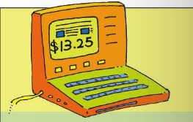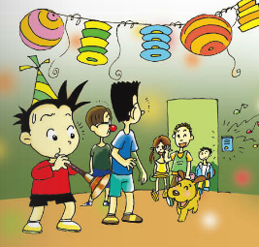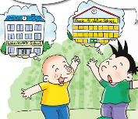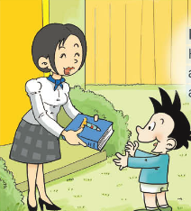
( ) ( ) ( ) ( ) ( )

- Listen and choose .听录音，根据录音内容选出正确的答案，并把相应的字母填入括号里。（每题2分，共10分）
1、 ( ) A 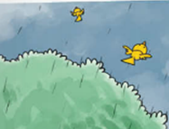 B 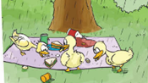
2、 ( ) A 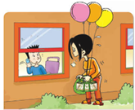 B 
3、 ( ) A  B 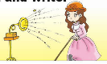
4、 ( ) A 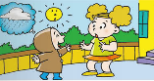 B 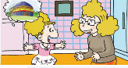
5、 ( ) A  B 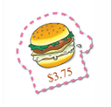

三、Listen and number.听录音，根据录音内容用数字给图片排序。（每小题2分，共10分）
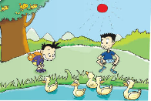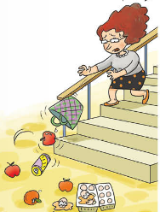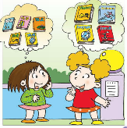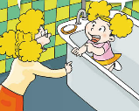
( ) ( ) ( ) ( ) ( )

四、Listen and write.听录音，根据录音内容选词填空。（每小题2分，共10分）
showed bought interested asked travel
It was Daming’s birthday yesterday. Simon’s mum _____ him a present. It was a book about space _______. Daming is very _________ in space travel. So he _________ Simon his present and _______ him to read the book with him. They love the book very much.

五、Listen and choose. 听录音，根据录音内容选择所听到的句子。（每小题2分，共10分）
1.( ) A. Why are you laughing? B. Why are you crying.?
2.( ) A. It will snow. B. It will be sunny .
3.( ) A.The birds are flying away. B. The cows are drinking water.
4.( ) A. Daming is playing the suona, but the phone rings .
B. Daming is playing the suona, but the bell rings.
5 ( ) A. Best wishes to you. B. Good luck to you.

六、Listen and answer.听录音，根据录音内容选择正确的答语。（每小题2分，共10分）
1、( ) A. At half past seven B.I want a hot dog.
2、( ) A. It will snow. B. It’s in the park.
3、( ) A.It’s three dollars and five cents. B. There are six.
4、( ) A. She is reading a book. B.She plays football.
5、( ) A. I’m going to school. B. I went to the zoo.

- Choose the right answers to fill in the blanks.选择正确的答案，并把答案的番号填写在题前括号内。（每小题1分，共10分）
1、( ) It ___ sunny in Harbin. A. will be B. will
2、( ) The balloons are _____away. A . fly B. flying
3、( ) Daming is playing the suona, ___the bell rings.
A. and B. but
4、( ) __are you crying? Because I’m sad. A. Why B. How
5、( ) I’m going to______History and Chinese. A. study B. look
6、( ) It good. A. look B. looks
7、( ) This old man can’t hear,because he is .
A. blind B.deaf
8、( ) What do you want to eat ? A. Meat B. Cola
9、( ) is the bag? It’s twenty yuan.
A. How many B.How much
10、( )Good luck the future. A for B. to

八、Read , then tick or cross. 读短文，根据短文内容判断句子正误，正确的打√，错误的打×。（每小题2分，共10分）
When you get to western countries, you should know some table manners when you eat with others, because different cultures. You can't start eating until everyone sits down. You eat with a knife and a fork, and use the knife with your right hand and use the fork with your left hand. When you don't use them, you can't wave them around.
Take your napkin, unfold it and put it on your lap. When you eat, you'd better not make eating noise. That's impolite. And you also can't talk loudly while eating. There are so many differences between Chinese table manners and western table manners.
( ) 1. When everyone is at the table, you can eat.
( ) 2. Use the knife with your left hand when you eat.
( ) 3. You use the napkin to clean your face.
( ) 4. When you are eating, you'd better not talk loudly.
( ) 5. If the food is delicious, you can make eating noise.

Read and choose. 读一读，选一选。（每小题2分，共10分）

Ma Lili’s parents are going to give a birthday party for her. She’s going to be fourteen years old. Ma Lili has a lot of friends. They are going to come to the party. They are girls from Ma Lili’s school. There are twenty-five of them.
Ma Lili’s mother is making birthday cakes for the party. They are very nice cakes. Ma Lili says to her mother, “Mum, you’re very nice. Thank you for your nice cakes.” Her father is going shopping. He buys a lot of apples, bananas, oranges and pears.
It’s four o’clock in the afternoon. Now everything is ready. The party begins in thirty minutes.
( ) 1. Who is going to give Ma Lili a birthday party?
A. Ma Lili herself B. Her friends C. MaLili’s parents
( ) 2. How many people are coming to Ma Lili’s party?
A. Twenty B. Twenty-one C. Twenty-five
( ) 3. Her mother ___ for her party.
A. is making cakes B. is shopping C. makes a cake
( ) 4. How old is Ma Lili going to be?
A. twelve B. thirteen C. fourteen
( ) 5. What time does the party begin?
- At four B. At half past four C. After four o’clock

九、Write. 写一写。（共10分）
暑假即将到来，你打算去哪里呢？为什么？你会去见什么人、做什么事呢？请根据自己的实际情况，请以My Summer holiday 为题，描述你暑假的计划。
提示： 1. 可以用be going to 或 will结构 ； 2. 请用5-10句话描述。

