**利用思维导图，多维互动，培养学生英语能力（一）**

——记林蓉名师工作室走进黄水小学

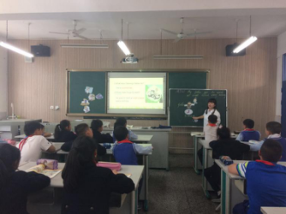 2017年4月18日下午，趁着春日暖阳，林蓉名师工作室的学员们在林蓉导师的带领下齐聚黄水小学，开展了轰轰烈烈的“利用思维导图，多维互动，培养学生英语能力”的英语研讨活动。本次活动首先由东升小学的杜芝敏老师、黄水小学的曾凌宇老师与黄水小学的五年学生分别带来了两节风格各异、精彩纷呈的同课异构《My father goes to work at eight o’clock every morning》。杜老师从“job”这一话题作为切入点，一步一步引导学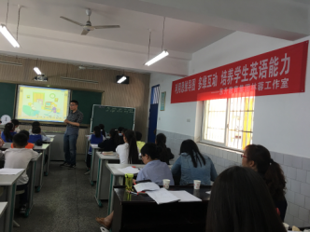生学习有关“job”和“working time”的学习，注重了学生思维开放性的培养，体现了学生学习的主观能动性。而曾老师则是由“working time”这一话题作为切入点，教学过程中与学生多维互动，培养了学生的英语思维。

课后，三所学校的老师在林蓉老师的引领下以这两节课为例，就“利用思维导图，多维互动，培养学生英语能力”开展了激励的讨论。大家一致认为：思维导图能帮助学生理清文本脉络，建构文本框架结构。要积极发挥学生的主观能动性，教师与之多维互动，激活学生的思维体系，从而培养学生的英语学习能力。

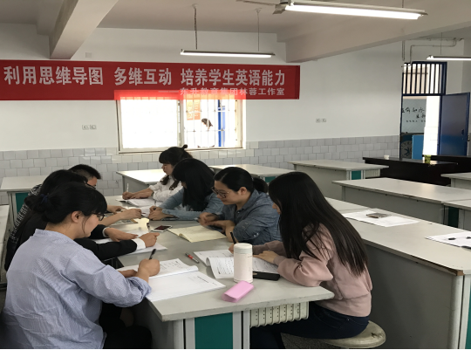

**标题：Module 7**

**Unit1 My father goes to work at eight o’clock every morning.**

**东升小学杜芝敏**

教学内容分析：在具体的语境中巩固与练习一般现在时和一般将来时.

学情分析：需要给学生创设层层递进，扎实有效的语境创设语句来让学生快速理解并掌握运用本课句型。

教学目标：  
一、教学目标(Teaching aims) （一）知识目标(Knowledge aims)

1. 听、说、读、写单词taxi, late, early, worker, evening，听、说、认读单词factory。 2. 听、说、读、写并运用句型My father/mother goes to work at … 表达自己的父母的上班时间；运用句型He’s/She’s a …描述某人的职业。 （二）能力目标(Ability aims) 1. 能够表达自己的父母的上班时间。 2. 能够描述某人的职业。

教学重难点：

1. 听、说、读、写单词taxi, late, early, worker, evening。

2. 运用句型My father/mother goes to work at …表达自己的父母的上班时间。 （二）难点(Difficulties)

当主语为第三人称单数时，谓语动词要用第三人称单数形式。 三、教学准备(Teaching preparation)

|  |  |  |  |  |
| --- | --- | --- | --- | --- |
| 教学方法：  教学过程 | 教师活动 | 学生活动 | 二次备课批注 | 设计  意图 |
| warm up | Greeting | Greetings |  | 轻松问候带领孩子进入英语课堂 |
| Lead_in  presentation | 1: Look, Listen and say. | ① What will they do tomorrow morning?  ② When will Mr Smart take them there? |  | 借助真实生活情景将课堂与生活情景建立联系。 |
| Learn text | 1.Look at the picture, Can you ask me any questions?  2. What are they talking about ?  3. Read the text and fill in the blanks. | Ask questions. What? Who? Where?  2. They are talking about their father and mother.  3. Fill in the blanks |  | 感知理解课文，并以恰当的问题迅速理清课文主线，掌握课文词句。 |
| consolidation | Repeat the text | Work in pairs and act it out. |  | 复述课文，巩固所学。 |
| Extension | Now write about your parents | Talk with classmates |  | 通过写的方式锻炼学生的书写能力 |
| Summary and homework | Copy the new words | | | |
| 板书设计 | Unit1 My father goes to work at eight o’clock every morning.   |  |  |  |  | | --- | --- | --- | --- | | Daming’s | What? | Where? | When? | | father | policeman | Police station | 8:00in the morning | | mother | nurse | hospital | 11:00 every night(late) |  |  |  |  |  | | --- | --- | --- | --- | | Fangfang’s | What? | Where? | When? | | father | worker | factory | 6:00 every evening(late) | | mother | Taxi driver |  | 5:30 every morning(early) | | | | |

**新标准英语三年级起点五年级下册Module 7Unit1教学设计**

**黄水小学 曾凌宇**

|  |  |  |  |
| --- | --- | --- | --- |
| M7U1 My father goes to work at eight o’clock every morning. | | | |
| 教材分析 | M7U1的课文情境是Daming 在上学的路上遇到Fangfang 。他告诉Fangfang，自己的父亲每天早上八点去上班，他是一名警察。Fangfang告诉Daming，她的父亲每天傍晚六点才去上班，他是一名工人。Daming又说，他的母亲每天晚上十一点去上班，她是一名护士。Fangfang说自己的母亲每天早上五点半就去上班，她是一名出租车司机。正在这时，Fangfang的母亲正好开着出租车经过，于是开车送他俩去了学校。  本单元的话题是说明活动、行为或事件发生的时间，本课是说明父母上下班的时间，学习之后要求学生能说明日常作息时间。在语言上主要是巩固一般现在时的用法。 | | |
| 课时教学目标 | 知识目标：   1. 词汇：能理解和运用单词evening, worker, busy. 2. 句型：能在课文语境下理解和运用My father goes to work at 8 o’clock every morning. He’s a policeman.   能力目标：  1. 能够听懂、理解，朗读，表演课文内容。  2. 能够理解和运用重点单词evening, worker, busy.  能够听懂，会说，并在情境中运用句型My father goes to work at 8 o’clock every morning. He’s a policeman.  情感目标：   1. 通过多种形式的活动，帮助学生树立自信心，鼓励学生敢于开口说英语，乐于表达并不怕出错。 2. 通过小组合作学习，培养学生的合作意识，主动了解他人的作息时间。 | | |
| 教学重点  与难点 | 1. 能够朗读课文，并表演课文。   2. 能够理解和准确运用句型：My father goes to work at 8 o’clock every morning. He’s a policeman. | | |
| 教学辅助 | PPT，教学光盘，点读笔，单词卡片，人物头饰等。 | | |
| 教学方法 | 游戏教学法，交际教学法，自主学习法，合作学习法，任务型教学法。 | | |
| 教学内容 | 教学活动 | | 设计意图 |
| 教师活动 | 学生活动 |
| Step 1: Warm up & Revision | 1. Greetings. 2. Play a guessing game.   T: Let’s play a game. What time is it? Guess! | 1. Greet the teacher. 2. Guess. | 通过师生之间的问候，营造宽松、愉悦的课堂氛围。通过猜一猜时间的游戏复习旧知，为后面重点句型的学习埋下伏笔。 |
| Step 2: Lead in | 1. Show a picture about activity 1. 2. Ask a question. 3. Q1: Will dad take Amy and Sam to the park tomorrow morning? 4. Watch and read. 5. Then show another question. 6. Q2: What time will dad take them to the park? | 1. Look and read the picture.  2. Watch and read, then answer the question.  3. Look and read the picture, then answer the question. | 在听读活动一前，教师通过先引导学生观察图片再设问，并让学生在回答问题的过程中加深对图片的理解。 |
| Step 3: Learn the text | 1. T: Look at the picture, who are Daming and Fangfang talking about?   Listen and watch the video.   1. Learn the text picture by picture.   P1:  T: Look at Daming’s father.  Q1: What does Daming say about him?  Q2: What does Fangfang ask Daming?  Watch and read.  P2:  T: How about Fangfang’s father?  Q1: What time does Fangfang’s father go to work?  Q2: What does he do?  Watch and read.  P3、P4:  T: Look at Daming’s mother and Fangfang’s mother, how about them? Would you please take out your different kind of sheet?  Then use information gap, ask T1 and T2 to ask each other some questions and finish their sheet.  Watch and read.    P5:  T: Look, who’s coming?  Listen and repeat.   1. Set a competition.   4. Show the five pictures of the text. | 1. Think about the question while watching the video. Then answer the question:   They are talking about ….  P1: Look at picture 1, listen, watch and read, then answer these questions.  P2:  Read the two questions, then watch and read, find out the answers.  Learn the key words: evening, actor and busy.  P3、P4:  T1 ask T2:  Q1: What time does Daming’s mother go to work?  Q2: What does she do?  T2 answer, T1 fill in the blanks.  Then T2 ask T1:  Q1: What time does Fangfang’s mother go to work?  Q2: What does she do?  T1 answer, T2 fill in the blanks.  Watch and read, then check their answers.  P5:  Read by themselves and answer.  Then listen and repeat after the reading pen.  3. T1 and T2 retell the text according to the blackboard design.  4. Choose the pictures they like, act out the text in roles. | 在引入对话时，通过观察图片，并询问引导性的问题来引起学生的思考，并播放整个没有字幕的文本动画，让学生通过听来初步整体感知文本。  逐图讲解，帮助学生加深对文本的理解及核心句型的运用，并有意识地让学生模仿语音语调。  在P1的教学环节中，以问题的形式开展师生交流，引导学生带着思考积极听音模仿，学习、理解P1。    在P2的教学环节中，教师抛出核心问题：What time…? What…?  让学生理解并能读出这些问句，为下一环节的教学奠定基础。  在P3、P4的教学环节中，通过利用信息沟，让一、二大组相互用What time…? What…? 来向对方寻求答案，获得信息，这样可以保持学生的学习兴趣，增强孩子交际的欲望，有效地促进语言的习得。  在P5的教学环节中，通过学生自读找到问题的答案，培养学生自主学习能力与独立思考能力。  通过复述课文，进一步加深孩子们对课文的理解。    通过表演课文，让孩子们在情境中准确地运用语言。 |
| Step 4: Practice | Play a game. | Choose the numbers they like, talk about the picture like this:  Shanshan’s father is a fireman.  He goes to work at 7:30 a.m.. | 通过游戏，把枯燥的语言学习变得充满活力，激发孩子的学习兴趣和求知欲，从而有效地提高课堂教学效率。 |
| Step 5: Product | 1. T: OK, today we’ve learnt: Daming’s father goes to work at 8 o’clock every morning. How about my daughter and me? Let’s watch.  Play the video.  2. T: This is my family. How about your family?  Show the key sentences:  My mother/father goes to work at_____.  She’s/He’s a/an ________.  I think she/he goes to work early/late.  She’s/He’s _______.  ... | 1. Watch the video.   2. Work in four and talk about their family members. | 通过谈论自己家人的作息时间，让孩子将今天所学的内容从课本迁移到自己的生活中，让语言更真实化、生活化，帮助孩子在真实的情境中运用所学的句型。 |
| Step 6: Homework | 1. Listen and read the text.★ 2. Recite the text. ★★ 3. Retell the text. ★★★ |  | 分层设计家庭作业，尊重学生的个体差异。 |
| Classroom Assessment | Divide the class into T1 and T2, if who can climb to the top of the ladder, who will be the winner. | | 通过分组竞赛爬梯子这一课堂评价，可以调动孩子学习的积极性和主动性，让孩子积极、主动地参与到课堂学习中来，从而提高课堂效率。 |