**外研版英语 (新标准) Book 2 Unit 2 Let’s celebrate!**

**Developing ideas**

**--Time for a Change?**

**教学设计**

授课老师：简阳市阳安中学 刘萍

授课时间： 2022.04

**外研版英语 (新标准) Book 2 Unit 2 Let’s celebrate!**

**Developing ideas--Time for a Change?**

|  |  |  |  |  |  |
| --- | --- | --- | --- | --- | --- |
| **教学内容分析**  **1.单元整体解读**  **板块**  **主题意义发展**  **内容**  感知主题，**认识**节日  了解世界节日及历史文化  Starting out  Understanding ideas  理解主题，**了解**节日  理解外国节日  及意义  Using language  内化主题，**描述**节日  比较中外节日之异同  深化主题，**传承**节日  探究中国传统节日，  传承其价值和意义  Developing ideas  深化主题，**传播**节日  传播传统节日，  弘扬中国传统文化  Presenting ideas  / Project  **2.【文本分析】：what, why, how**  What: 主要内容和主题意义  文本呈现了两代人对年夜饭的习俗是否应该改变发表不同的观点。  Why:作者意图  使学生能够加深对传统节日发展的理解，探讨文化传承的价值与意义，形成批判性看待事物发展的思维。  How： 文体结构，语言特点  本语篇类型为报纸专栏，包含读者的两封来信，每封信主要包含三方面的内容，即发表对年夜饭形式的观点，说明理由，并给出大量细节支撑陈述的理由。此语篇中包含大量与春节有关的词汇短语，且有大量表达观点类的语言结构。 | | | | | |
| **学情分析**  **1.话题知识：**  已具备：学生在初中阶段以及课外已经接触过与节日相关的话题，例如festivals, holidays and celebrations 等。  待提高：学生对于节日与文化之间的思考较浅显。  **2.语言知识：**  已具备：学生通过初中或者更早的学习，已了解部分关于春节及相关节假日的语言表达方式。  待提高：学生在描述节日的庆祝方式，表达观点等方面语言不够准确。  **3.思维能力：**  已具备：学生具备辨析语言和文化基本现象的能力，能够梳理概括文本信息，能对事物作出自己的价值判断。  待提高：学生判断不同观点和思想的价值、并形成自己的观点的能力有待提高，客观分析不同信息之间的内在关联和差异的能力有所提高。 | | | | | |
| **教学目标**  By the end of the class, we will be able to:   1. **identify** the different opinions about Spring Festival family dinner by reading. （学习理解类） 2. **conclude** the way to support the opinions by analyzing. (应用实践类) 3. **share** our own opinions on the change of the Spring Festival family dinner. （迁移创新类） | | | | | |
| **教学重点**   1. conclude the way to support the opinions by analyzing. 2. share our own opinions on the change of the Spring Festival family dinner. | | | | | |
| **教学难点**  share our own opinions on the change of the Spring Festival family dinner. | | | | | |
| **教学过程** | | | | | |
| **时长** | **步骤** | **英语学习活动观活动类型** | **教学活动** | **设计意图** | **核心素养培养点** |
| 5mins | Lead-in | 学习理解类 | Activity1: Brainstorm  Teacher:  Provide some related pictures and ask the following questions.   1. A few days ago, we had a three-days off, and didn’t go to school, and why? 2. There are seven official holidays in China. What are they? 3. Among these holidays, which one is the most important for us? 4. What are the traditions of Spring Festival? 5. Where do you have the Spring Festival family dinner? | 利用问题及图片创设情境，激活语言知识及节日背景知识，并引入到春节话题，最后聚焦到春节年夜饭的形式。为本节课的话题阅读作铺垫。 | 文化意识  思维品质 |
| 22mins | While-reading | 学习理解类 | Activity 2: Read for Opinions  Teacher:  Read the letters quickly and find out whose opinion it belongs to?  Tip: Pictures can give you hints！  Activity 3: Read for Structure  Teacher:  What are the reasons and supporting details of these two different opinions?  C:\Users\98494\AppData\Local\Temp\1649583066(1).png | 培养学生观看图片的阅读策略，提高“看”的技能，感知年夜饭形式的变化，并辨别两位读者的观点。  引导学生梳理文本信息，学习语言，提炼结构，并感知表达观点的方法，培养学生的逻辑思维，加深对主题意义的理解。 | 语言能力  学习能力  语言能力  思维品质 |
| 13mins | Post-reading | 应用实践类  迁移创新类  迁移创新类 | Activity 4: Think & Share  Teacher:  Group work  Give a talk about which of the two opinions you agree with.  To cook at home / To eat outside?  Activity 5 Read and Analyze  Teacher:  1.Why do they have different opinions on the same tradition?  2.What do these two opinions have in common?  No matter where and what we eat, the love between family remains the same.  Embrace the changes, embrace the culture. | 培养学生小组合作意识，并内化迁移所学（结构、内容、语言）进行表达，增强对主题的理解。  分析不同观点背后的原因，以及观点的共性，培养学生的思维品质。并在情感上引导学生感受到祖国的发展变化，提高民族自豪感，并加深对主题的理解。 | 语言能力  学习能力  思维品质  思维品质  文化意识 |
| **板书设计**  C:\Users\98494\AppData\Local\Temp\1649583066(1).png | | | | | |
| **教学反思**  以下为本次备课和上课中进行的自我反思：   1. 以单元主题意义为灵魂，注重核心素养的综合发展。文化育人+思维品质发展。2.设计教学活动时践行英语学习活动观，为学生设计有情境，有层次，有实效的英语学习活动。   3.教学时间紧张，迁移创新类活动设计有限。 | | | | | |

**外研版英语 (新标准) Book 2 Unit 2 Let’s celebrate!**

**Developing ideas--Time for a Change?**

**导学案**

简阳市阳安中学 刘萍

**Activity 1 Brainstorm**

What are the traditions of the Spring Festival?

**Activity 2 Read for Opinions**

Read the letters quickly and find out whose opinion it belongs to?

______________ ______________

having the family dinner in a restaurant having the family dinner at home

**Activity 3 Read for the Structure**

opinions reasons supporting details(支撑细节)

1. _______ is changed, but _____ is the same.

2.The __________ are hard work.

3. It has nothing to do with_______________.



1.______________________

2.______________________

3.________________________

1.______________________

2.______________________

2.

out

**I**

**Mom**

**Family**



1.______

2._____

3._____

4.______

1.____

2.____

3.____

4.____

1.___________2.___________

1.Having dinner out won’t ___________________.

2. The _________ is even more important.

at home

activities

**Activity 4 Think & Share**

Group work:

Give a talk about which of the two opinions you agree with.

To cook at home / To eat outside?

You may refer to the following expressions:

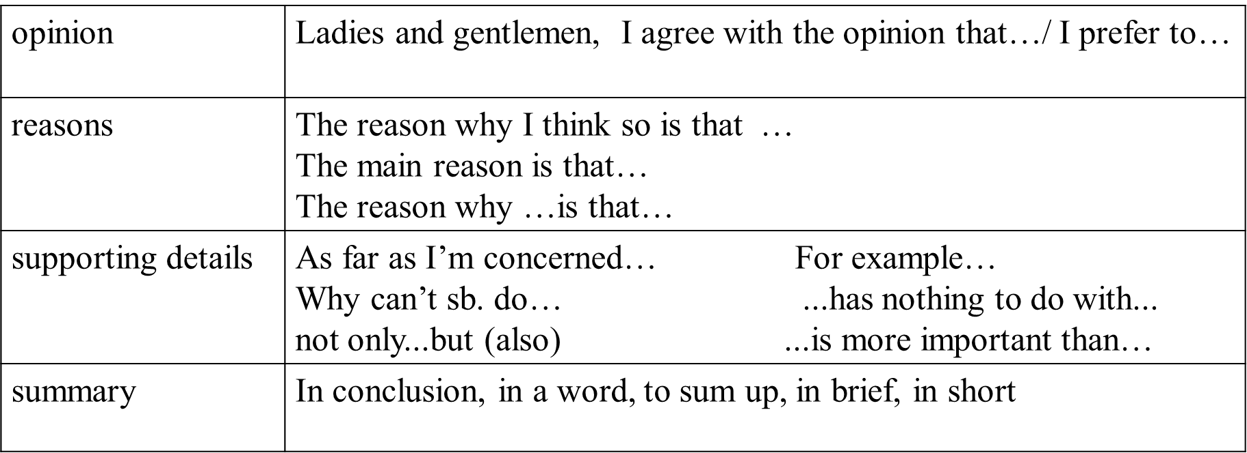

**Activity 5 Read and Analyze**

Group work:

Read the passage and analyze:

1. Why do they have different opinions on the same tradition?
2. What do these two opinions have in common?

**No matter where and what we eat, the *love* between family *remains the same*.**

**Embrace the changes, embrace the culture.**