***Book1Unit6 At one with nature***

**Understanding ideas：Longji Rice Terraces**

**Lead in**

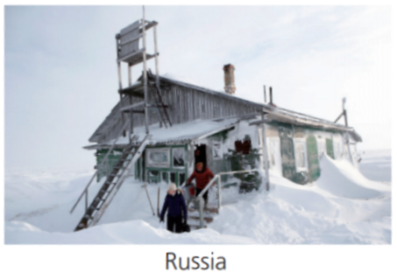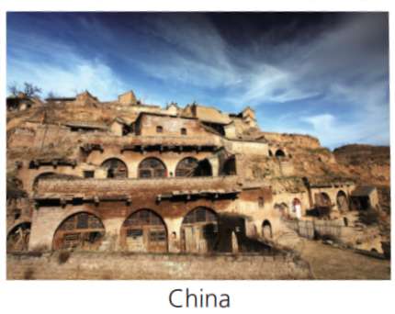

In Russia, it can get very cold with heavy snow in winter, so people build houses with inclined roofs（倾斜的房顶）. Therefore, the heavy snow won't crush the roof.

In north-west China, because the yellow earth is thick and compacted(坚实的), people build cave dwellings(窑洞) as their place of residence(居住地). And the cave-house is warm in winter and cool in summer.

1.How does the natural environment influence the lives of the local people in each picture?

2.In which country do local people build this kind of house to adapt to nature?

In which country do local people build this kind of house to make use of nature?

**Activity1:View and predict**

Look at the picture and predict what aspects this passage is going to talk about ?

___________________________________________________________________________

**Activity2:Read, check and summarize**

Which aspects are likely to be talked about in the passage?

**Activity3:Read and answer**

Para1_______________:How can you describe the seasonal beauty of the terraces vividly?

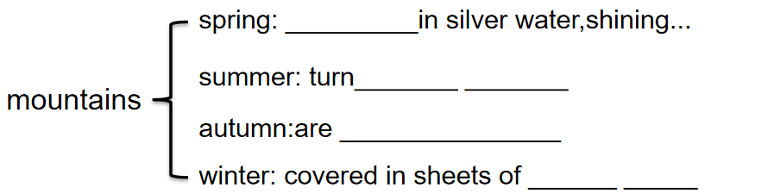

Para2_______________:

1.Who built the terraces?

1. When did people begin and complete the terraces ?
2. What evidence show it is a vast project?

Para 3_________________:

Why did local people go to so much trouble to turn the entire mountains into terraces?

Firstly,few___________areas increase the areas to grow rice

Secondly, _______ mountains and_________ soil catch the _________and prevent___

Para4___________________:

1. How do these terraces work?(waterway:rainwater;the sun;rain...)
2. Do you think the terraces help the ecological cycle of nature(自然生态循环)? Why?

Para5___________________:

What is the value the terraces bring to the local people?

**Activity4 Read and think**

1. What’s genre(文体) of the text?( ) A.narrative B. exposition C. argumentation
2. What’s the author’s purpose in writing the passage? ( )
3. To praise the wisdom of the ethnic groups living in Guangxi Zhuang Autonomous Region.
4. To explain how people worked in harmony with nature to create the Longji RiceTerraces.
5. To describe the beauty of the Longji Rice Terraces and to attract visitors to this scienic spot.

**Activity5:Conclude and retell**

Based on what we have learned, retell the passage according to the mind-map.

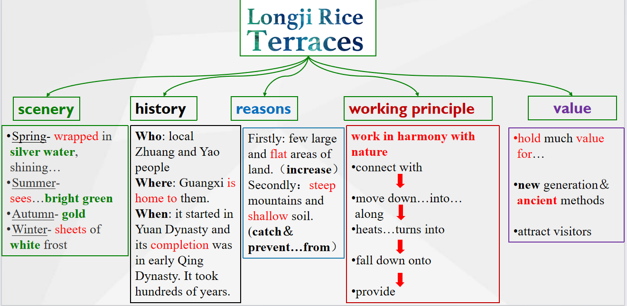

**Activity6:Think and share**

1.When human wisdom meets natural beauty, could they change nature at will(任意地)? And how do we live in harmony with nature?

_____________________________________________________________________

2.Can you find one example of human living in harmony with nature in Sichuan?

Introduce it from its history, working principle,and value.

**Assignment**

Write a passage to introduce Dujiangyan .